Github Account:

<https://github.com/ChhornKakada/Intenet_Programming/tree/tp13>

**Noted**: I only done with API.

# Implementation of using Redis

This is how I implement Redis.

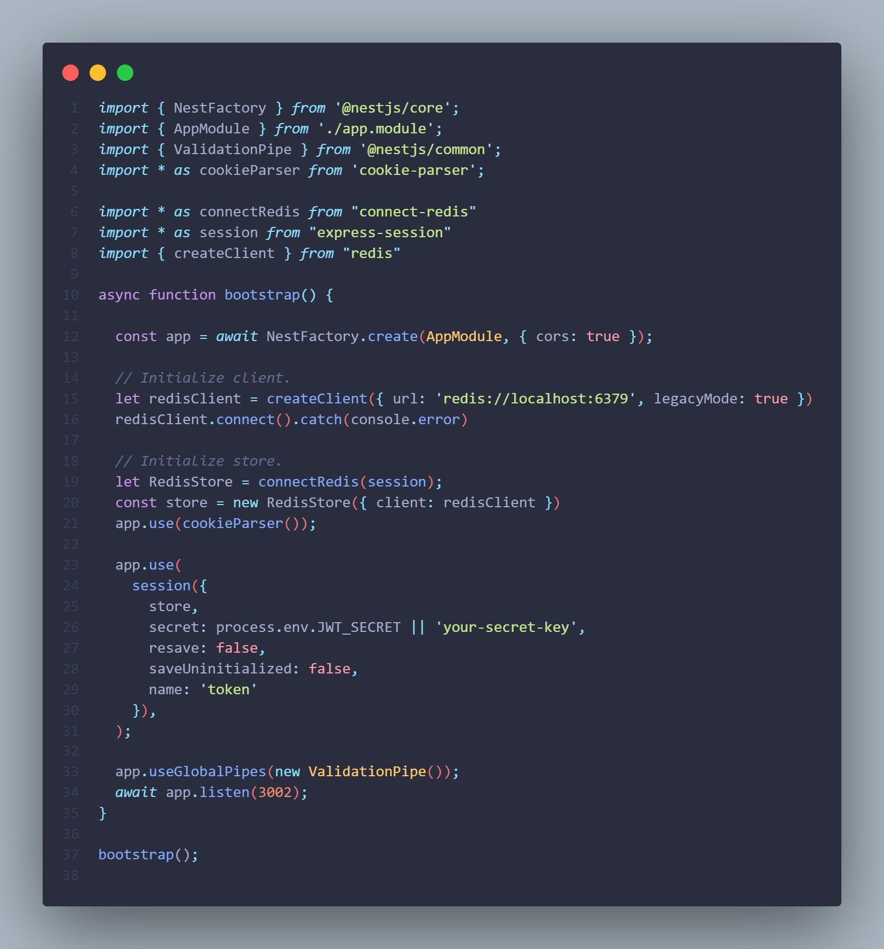

# File management

This is the class I implement for **File Management**.

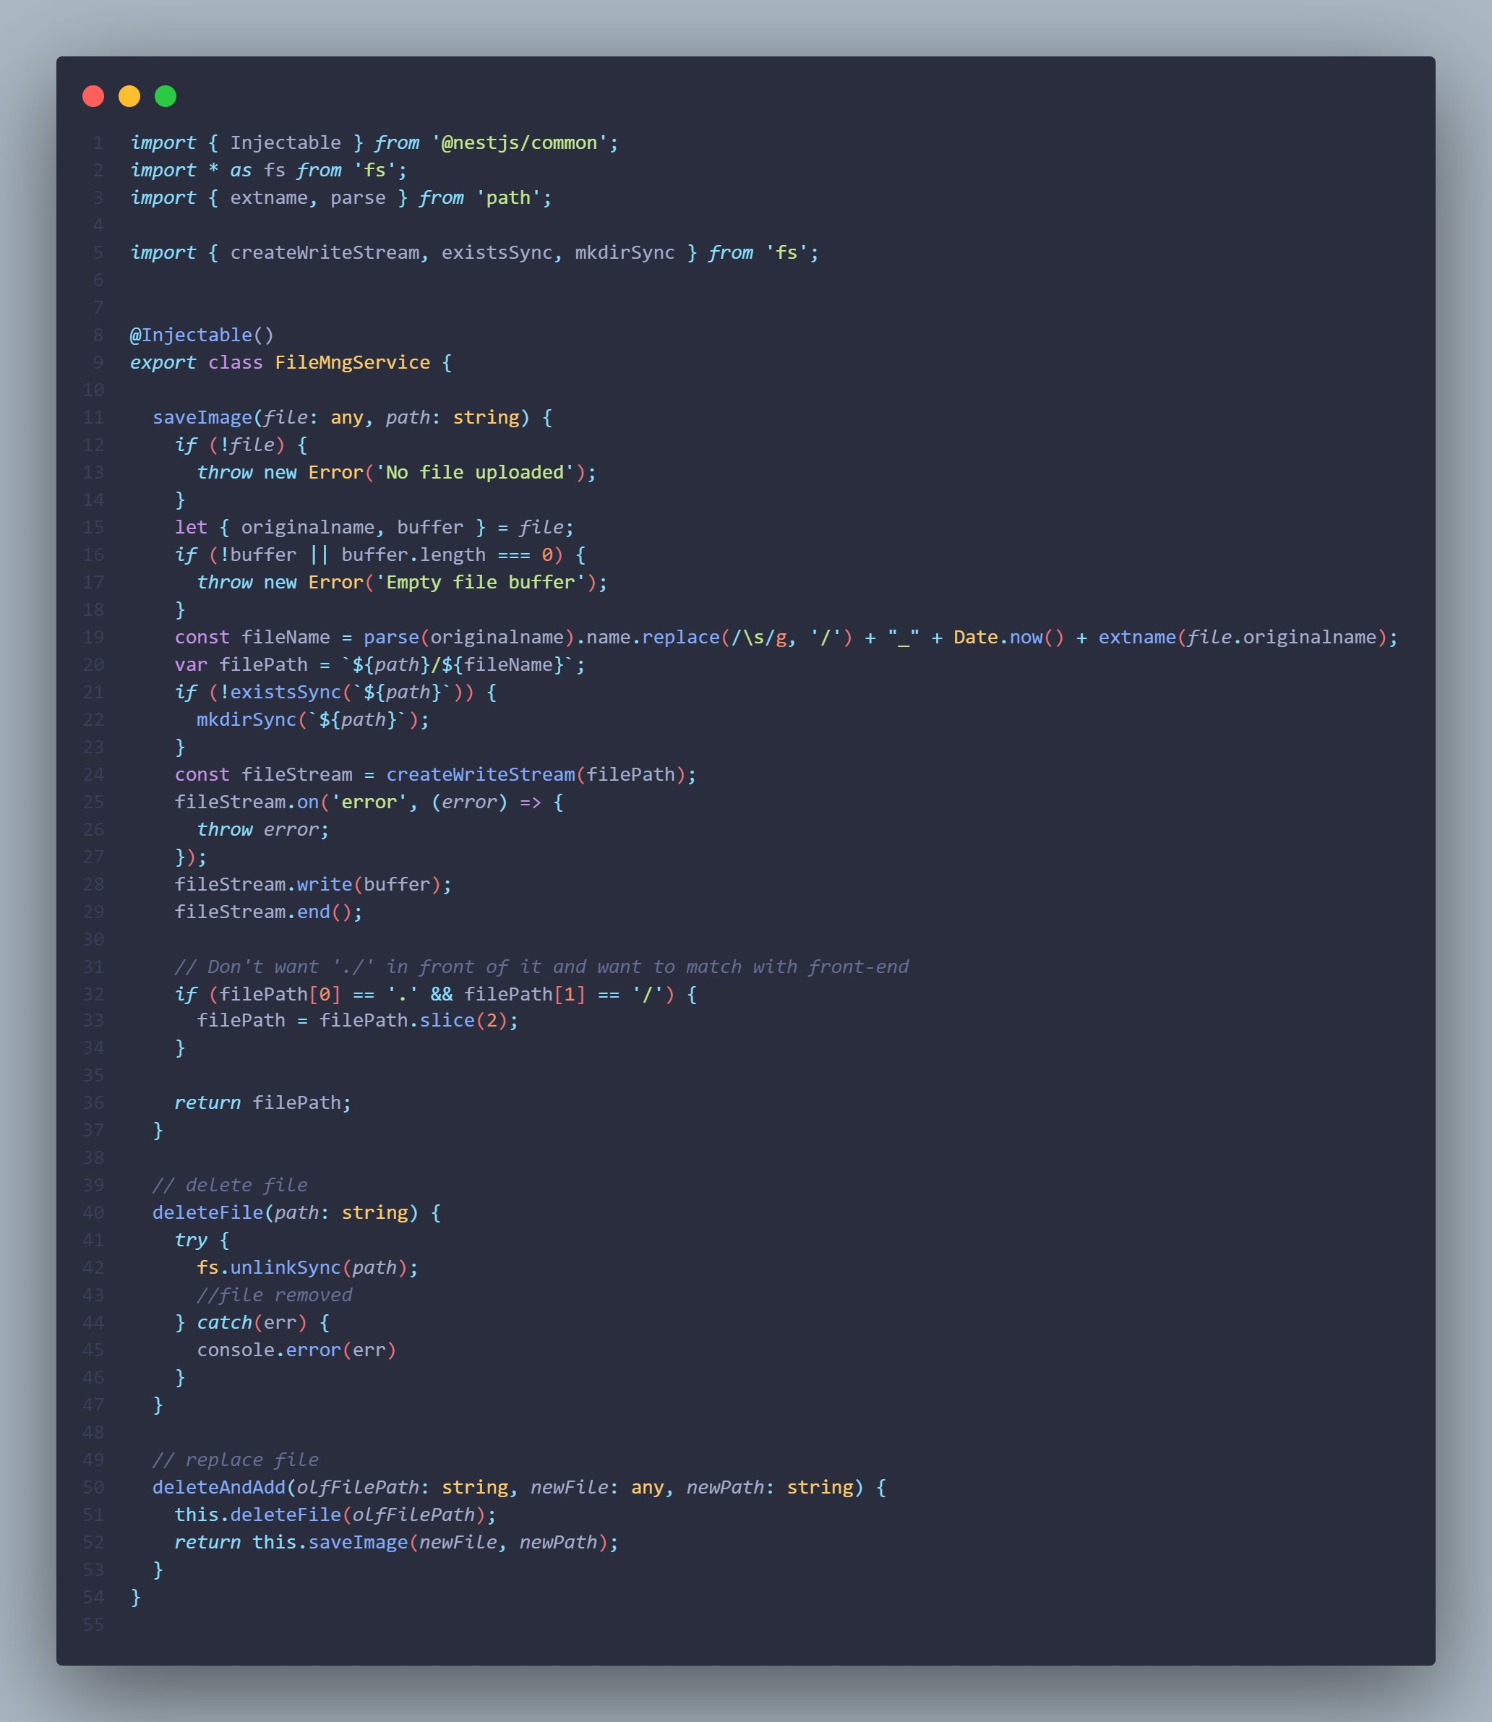

# How to access picture in the Url

To access any picture in the Url, we need to modify some code in the **app.controller.ts** to enable user to access it.

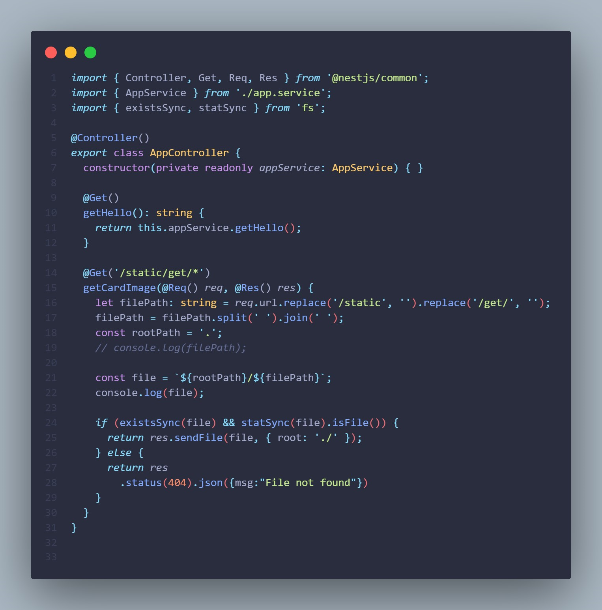

You can access the picture by follow the structure of the image below:

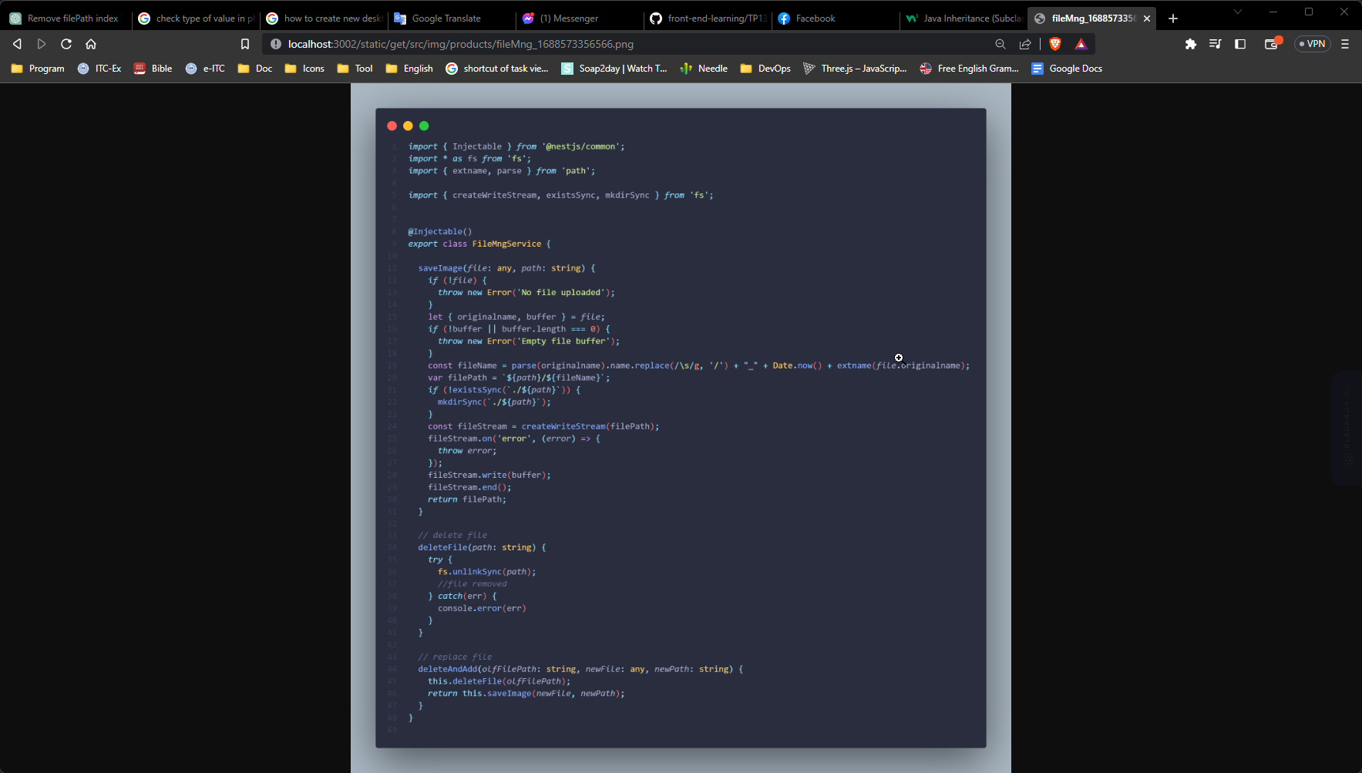

# Create product with image

Now you can add product with image by using **form-data**.

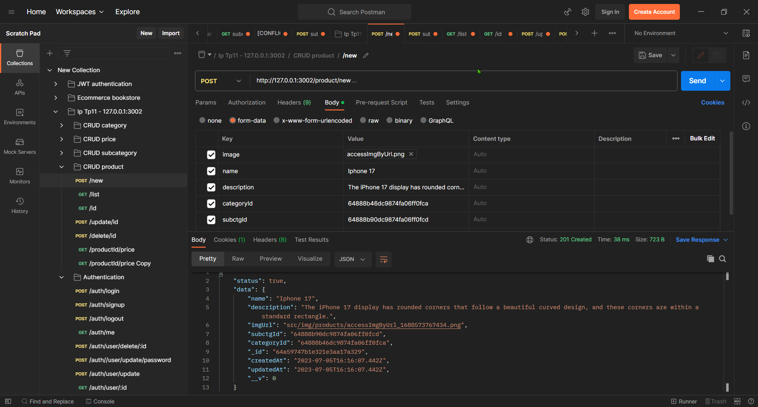

And this is the file we have stored in the folder **src/img/products**

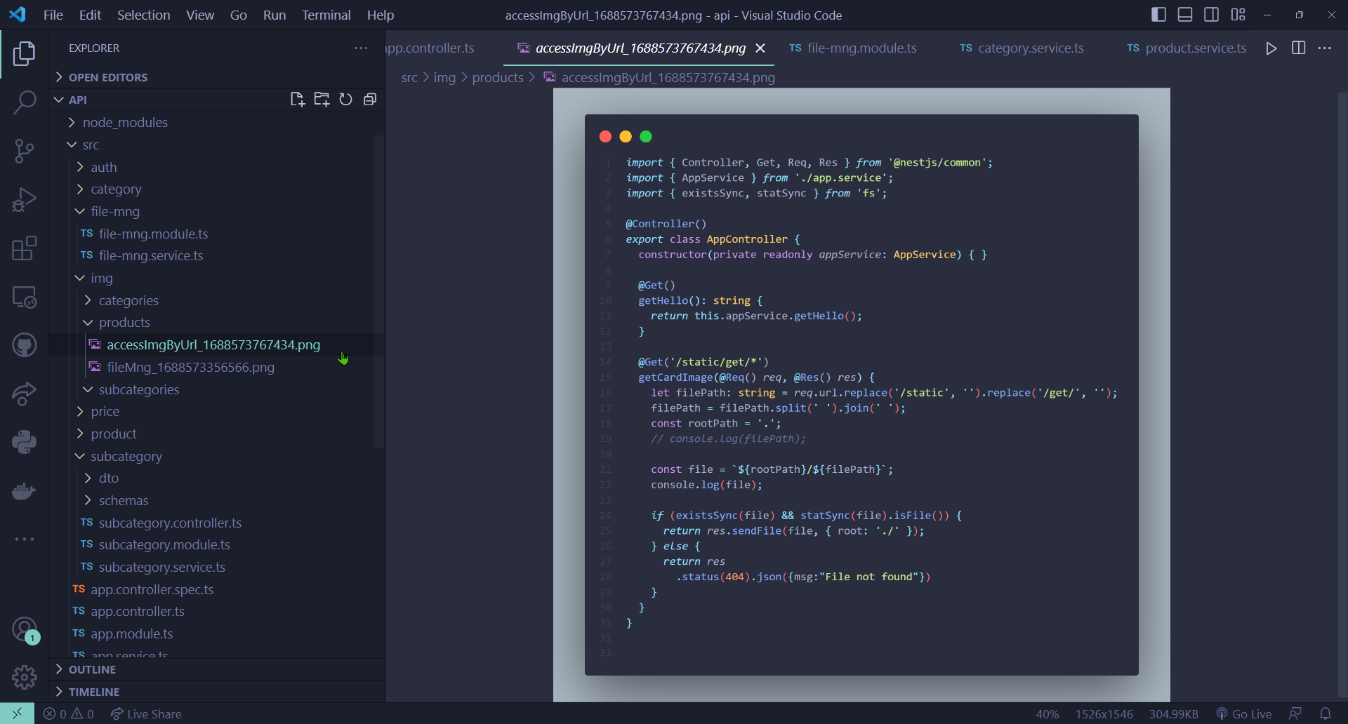

# Update product with image

You can update the image of the product too, it will delete the old image in the folder, then add the new one in the same directory.

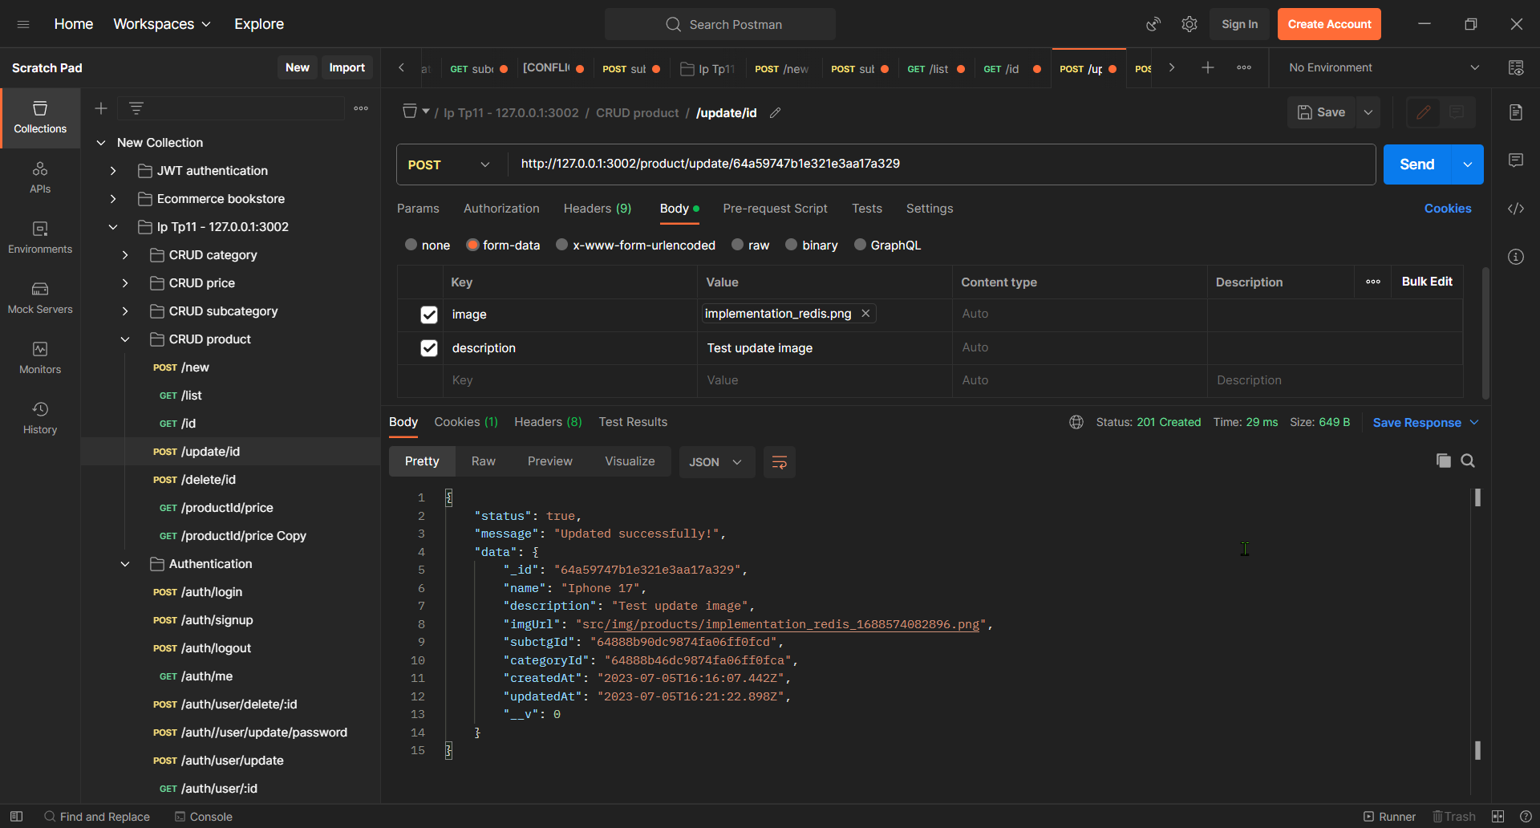

This is the changing of image that store in the directory **src/img/products**

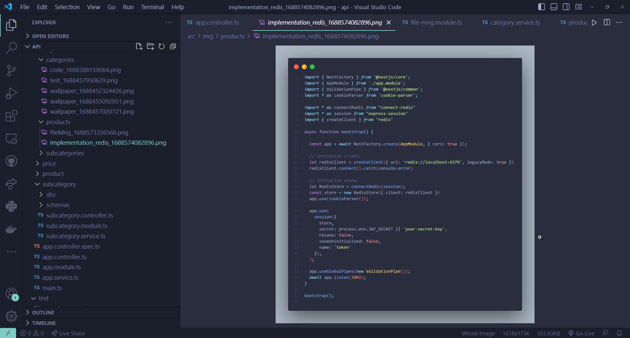

# Delete product

When you delete product, it will delete in the database then delete the image in the directory.

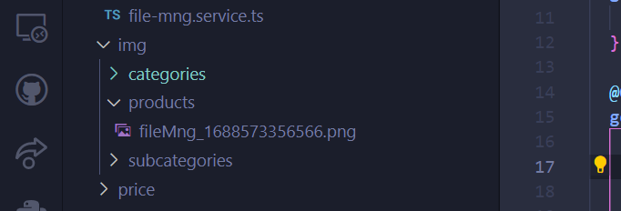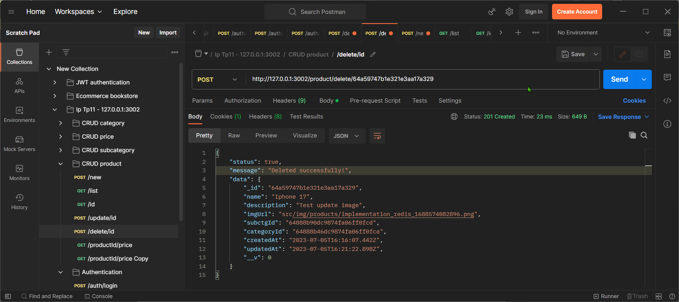

**Noted**: for the **category** and **subcategory**, I have implemented the same as **product**.